**System Design Specification**

**for**

**Developing a building material sale**

**Version 1.0.1**

**Guided by: Nguyễn Thành Ý**

**Written by: Team4_SE1637**

**Hanoi, February, 2023**

**Contents**

1 Document Management 2

1.1 Contributors 2

1.2 Version Control 2

2 OVERVIEW 3

3 DEVELOPMENT TOOLS AND STANDARDS 4

3.1 Development Tools 4

3.2 Development Standards 4

4 SYSTEM PROCESSES 5

5 USER INTERFACE 6

5.1 Transactional Interface 6

5.2 MyEd Interface 6

5.3 Reporting Interface 6

6 APPLICATION SECURITY 9

6.1 Authentication 9

6.2 Business Objects 9

7 DATABASE DESIGN 10

7.1 Database schema……………………………………………………………**10**

7.2 Table description……………………………………………………………**10**

8 APPLICATION INTERFACES 12

9 DATA 15

10 IMPLEMENTATION 15

# Document Management

*When completing this document, please mark any section that is not required as ‘N/A’. A brief description of why the section is not required should also be included.*

## Contributors

Please provide details of all contributors to this document.

|  |  |  |
| --- | --- | --- |
| **Role** | **Unit** | **Name** |
| Systems Analyst Designer (Owner) | The systems analyst designer will be the main contributor to the document, responsible for defining the technical requirements, overall design, and structure of the website. They will oversee the document creation and collaborate with other contributors to ensure the accuracy and completeness of the document. | Cường |
| Business Analyst | The business analyst will provide the business requirements, such as the types of finished steel products, quantities, pricing, and customer profiles. They will work with the project team to ensure that the website meets the business requirements. | Tùng |
| Project Manager | The project manager will oversee the project and ensure that all deliverables are completed on time and within budget. They will manage the overall structure and content of the document, and collaborate with other contributors to ensure that the document is complete and accurate. | Hòa |
| Business Area Manager | The business area manager is responsible for the area of the organization that the website will serve. They will provide guidance on the business requirements, and ensure that the website aligns with the strategic goals of the organization. | Lân |
| *Other document contributors* | Other contributors to the document may include developers, quality assurance team, user experience designers, and other subject matter experts who will provide input on specific technical requirements and design elements. | Ninh |

## Version Control

|  |  |  |  |  |
| --- | --- | --- | --- | --- |
| **Date** | **Version** | **Author** | **Section** | **Amendment** |
| 2023-01-15 | 1.0 | Hòa | All | Initial version created |
| 2023-01-26 | 1.1 | Hòa | 2 | Add some admin functions |
| 2023-01-31 | 1.2 | Tùng | 3.1 | Add some user functions |

# OVERVIEW

-) The system design specification document outlines the technical requirements and design of a website that sells finished steel products such as scaffolding, steel poles, formwork, and accessories. The website will allow customers to browse and purchase products online, as well as view product details, pricing, and availability.

-) The system design will be implemented using a web-based architecture, with a front-end user interface that is accessible via a web browser, and a back-end database that stores product data and customer information. The website will be designed with a responsive layout to ensure that it is optimized for use on desktop and mobile devices.

The website will provide several key features, including:

# Product Category: The website will have a comprehensive Category of all available finished steel products, with product details such as specifications, dimensions, and pricing.

# Search and Filtering: The website will allow customers to search and filter products based on various criteria such as product type, size, and price.

# Shopping Cart: Customers will be able to add products to a shopping cart, view the contents of their cart, and checkout to complete their purchase.

# Account Management: Customers will be able to create an account, save their payment and shipping information, view order history, and manage their account settings.

# Customer Support: The website will provide customer support through a contact form, a phone number, and an FAQ section.

# 

# DEVELOPMENT TOOLS AND STANDARDS

## Development Tools

* Programming Language: The system will be developed using C#.
* Web Framework: The system will be built using the .NET core 6.0.
* Front-end Framework: The front-end will be developed using HTML, CSS, JS, Bootstrap, Sass.
* Database: The system will use MySQL as the primary database.

## Development Standards

Tick the appropriate box to indicate the standards being followed for this application:

|  |  |
| --- | --- |
| **Standard** | **√ indicates compliance** |
| Database Design | **√** |
| Cold Fusion | **√** |
| C# | **√** |
| Accessibility | **√** |
| Web Style Standards | X |
| Supported Web Browsers | **√** |

# SYSTEM PROCESSES

1. User Registration (BRD Paragraph 2): The website will provide a user registration form that collects the user's personal information, such as name, email, phone number, and address. Upon submission, the website will create a new user account and store the user's information in a database.
2. Browse Products (BRD Paragraph 3): The website will display a product catalog page that lists all available products, including iron and steel, scaffolding, steel support columns, formwork, accessories. Each product will be displayed with its name, image, description, and price.
3. Product Details (BRD Paragraph 4): The website will provide a product details page that displays more information about a specific product when a user clicks on it in the product catalog page. The page will show the product's name, image, description, price, and any other relevant details.
4. Add to Cart (BRD Paragraph 5): The website will allow users to add products to their cart from both the product catalog page and the product details page. When a user clicks the "Add to Cart" button, the website will update the user's shopping cart and display a confirmation message.
5. View Cart (BRD Paragraph 6): The website will provide a shopping cart page that displays all the products the user has added to their cart. The page will show each product's name, image, description, price, and quantity. The user will be able to modify the cart contents by updating the quantity of each product or removing products from the cart.
6. Checkout (BRD Paragraph 7): The website will provide a checkout page that collects the user's shipping and billing information, as well as their preferred payment method. The page will display a summary of the order, including the products in the cart and their total cost.
7. Payment Processing (BRD Paragraph 8): The website will securely process the user's payment using a third-party payment gateway, such as Stripe or PayPal. The payment gateway will return a transaction ID, which the website will store in the database for future reference.
8. Order Confirmation (BRD Paragraph 9): Once the payment is successfully processed, the website will display an order confirmation page that shows the order details, including the products in the order, the shipping address, and the total cost. The website will also send an order confirmation email to the user, containing the same information.
9. Order fulfillment (BRD Paragraph 10): The website will notify a staff member responsible for checking the company's account balance to verify that the payment has been received. The staff member will use the transaction ID from the payment gateway to verify the payment. If the payment is confirmed, the staff member will update the order status to "fulfilled".
10. Shipment (BRD Paragraph 11): The website will generate a shipping label and send the order to the shipping provider, such as UPS or FedEx. The website will store the shipping tracking number in the database for future reference.
11. Delivery Confirmation (BRD Paragraph 12): The website will send a delivery confirmation email to the user, containing the shipping tracking number and instructions on how to confirm delivery. The website will also notify the staff member responsible for checking the company's account balance of the delivery confirmation.
12. Returns and Refunds (BRD Paragraph 13): The website will provide a returns and refunds policy that allows users to return products or request a refund. The website will allow users to initiate a return or refund request by filling out a form that collects the order number, product details, and reason for the return/refund

# USER INTERFACE

## Transactional Interface

-) The transaction interface will take the customer's data from the database and then automatically fill in some required fields, in addition, the interface allows the user to edit the shipping address if the customer wants. change the address.

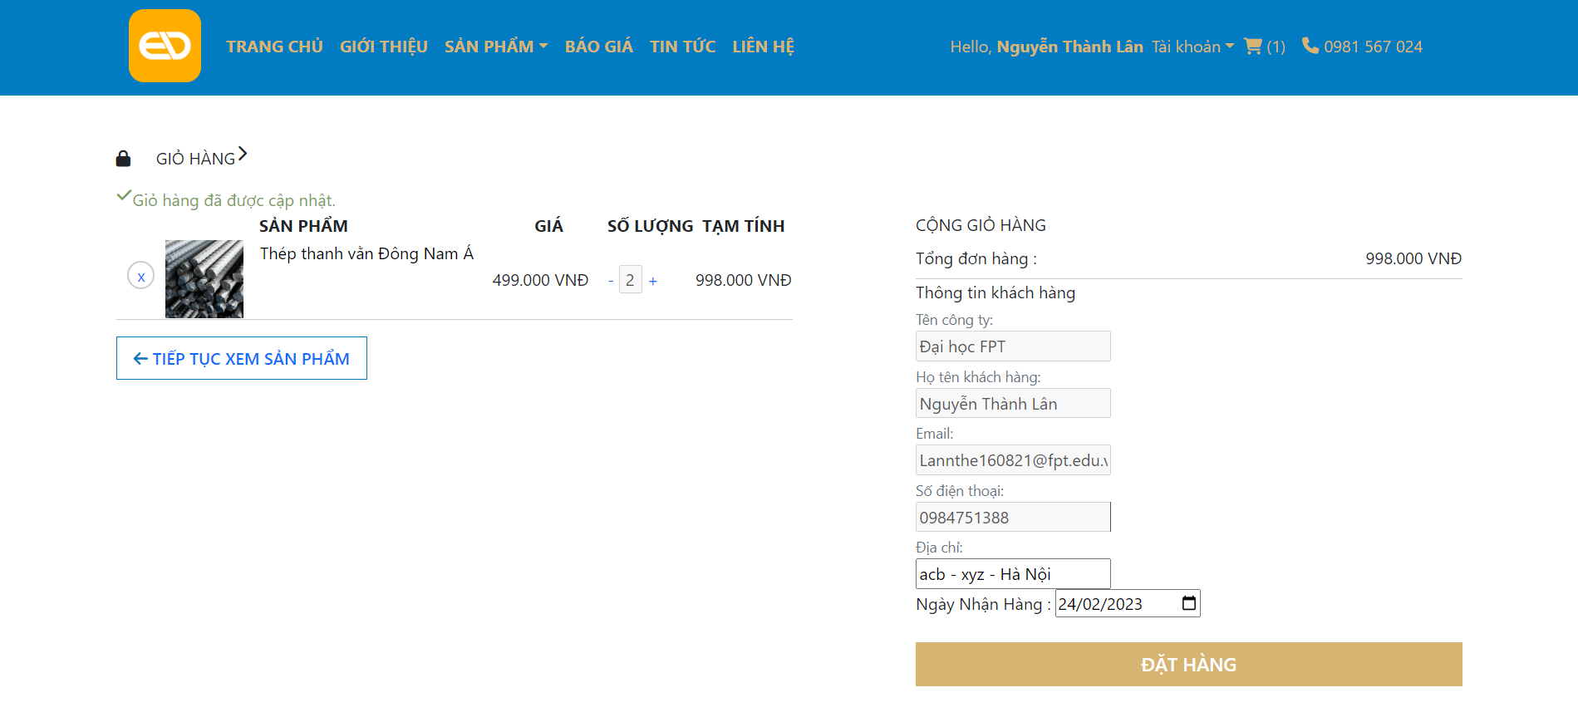

## MyEd Interface

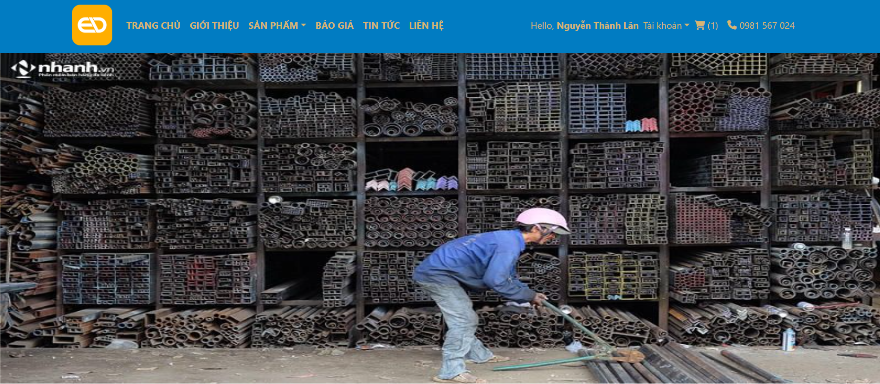

## Reporting Interface

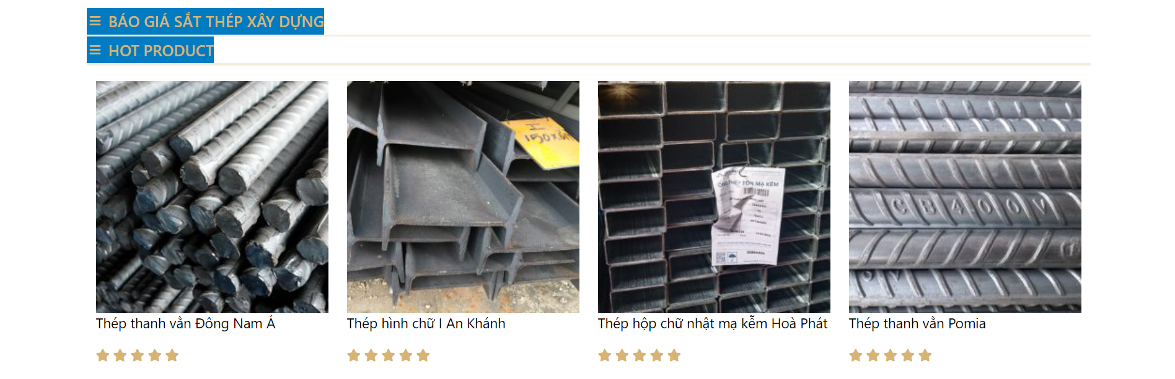 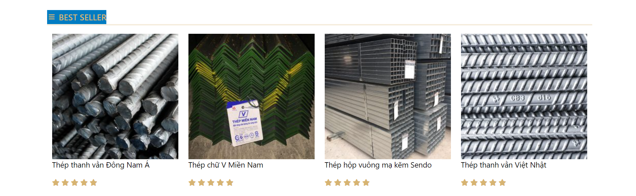 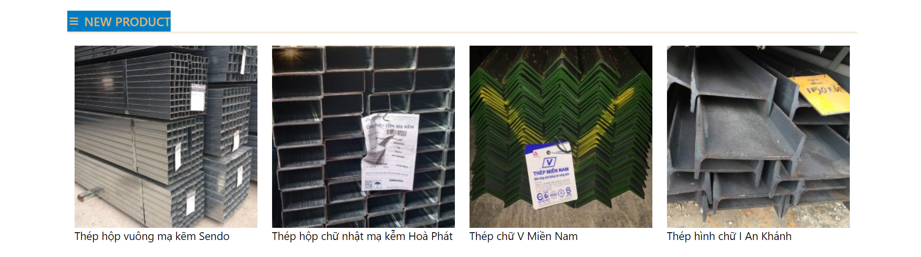

# APPLICATION SECURITY

## Authentication

The system has a login function for users. If customers want to order a product or chat with the employee they have to login to the system. The employee or admin have to login to check or edit the information of the website.

## Business Objects

* Users: they can view the information and order the product, chat with employees and other customers.
* Employees: can see the information and they can add, update or delete the product or any information on the website. They can view the list of Q&A and chat with the customers.
* administrator: can view all the information of the website such as the detail of orders, the information of customers and the data of the website.

# DATABASE DESIGN

## Database schema

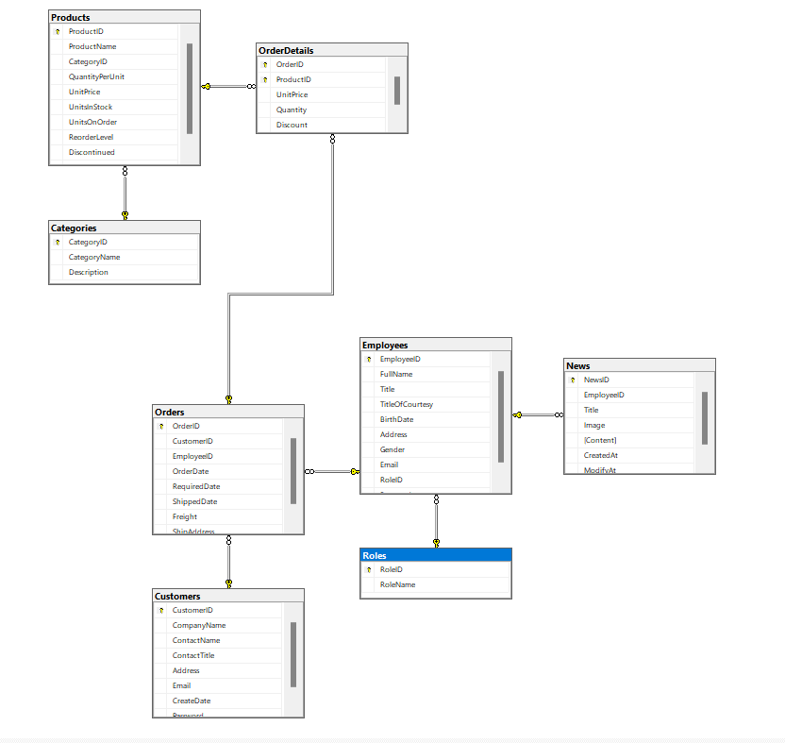

## Table description

* Products table contain: Product id (int), Product name (nvarchar), Category id (int), QuantityPerUnit (nvarchar), UnitPrice (float), UnitsInStock (int), UnitsOnOrder (int), ReorderLevel (int), Discontinued (bit), Description (ntext).
* OrderDetails table contains: Order id (int), Product id (int), UnitPrice (float),

Quantity (int), Discount (float).

* Categories table contains: Category id (int), Category name (nvarchar), Description (ntext).
* Orders table contains: Order id (int), Customer id (int), Employee id (int), Order date (datetime), Required date (datetime), Shipped date (datetime), Freight (float), Ship address (nvarchar).
* Employees table contains: Employee id (int), Full name (nvarchar), Title (nvarchar), TitleOfCourtesy (nvarchar), Birth date (datetime), Address (nvarchar), Gender (bit), Email (varchar), Role id (int), Password (varchar).
* News table contains: News id (int), Employee id (int), Title (nvarchar), Image (nvarchar), Content (ntext), Created at (datetime), Modify at (datetime).
* Customers table contains: Customer id (int), Company name (varchar), Contact name (varchar), Contact title (varchar), Address (nvarchar), Email (varchar), Created date (datetime), Password (varchar).
* Roles table contains: Role id (int), Role name (nchar).

# APPLICATION INTERFACES

* Main screen:

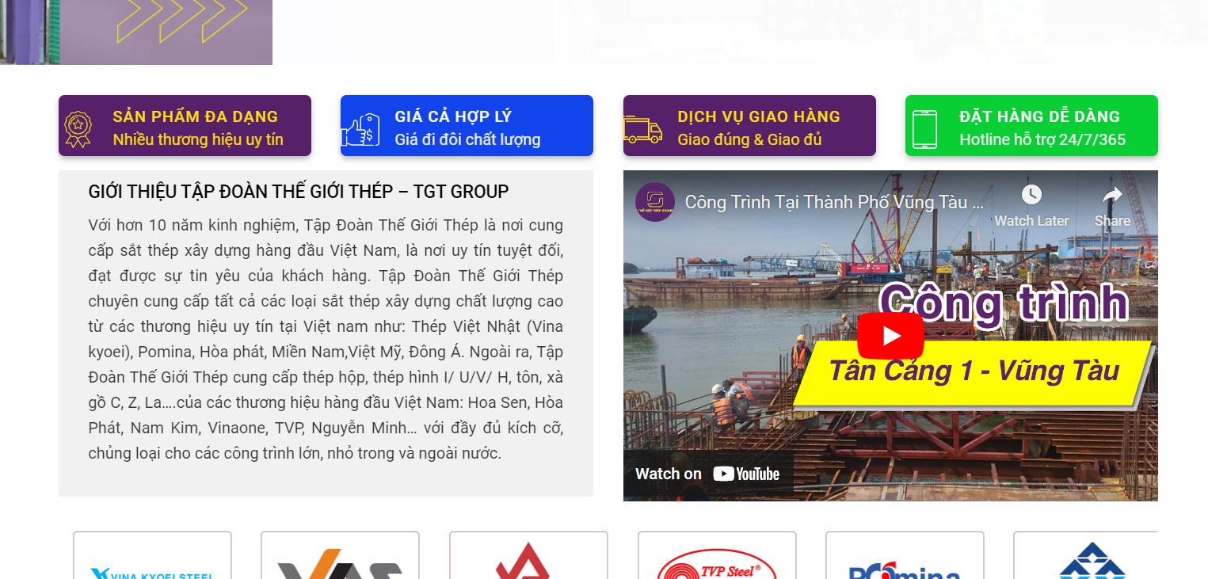

* Sign in:

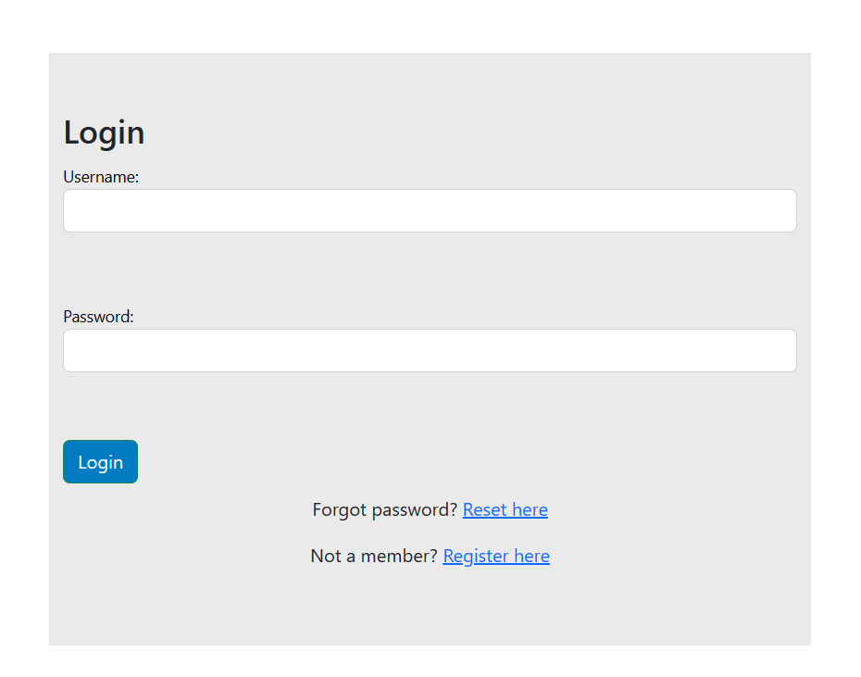

* Sign up:

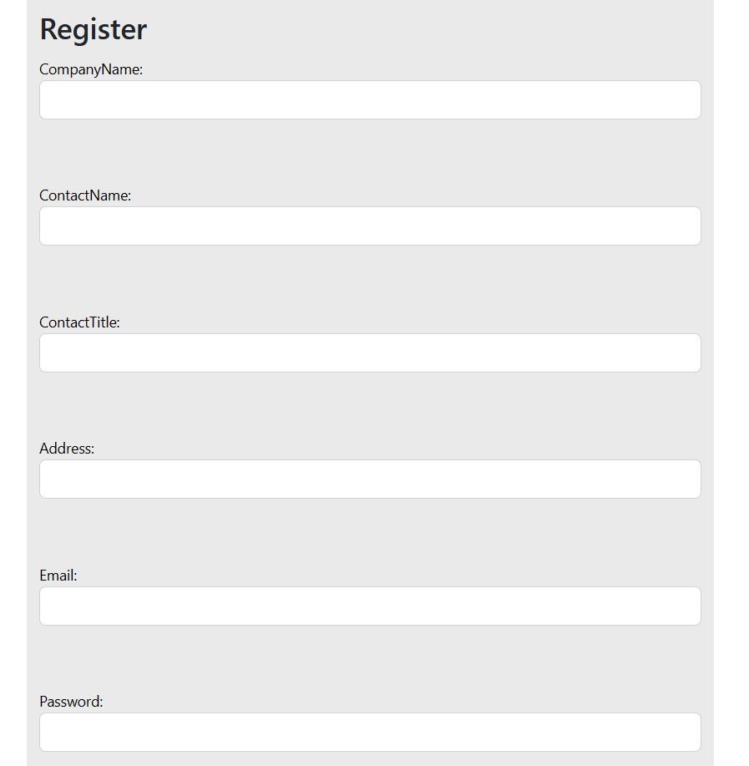

* Forgot password:

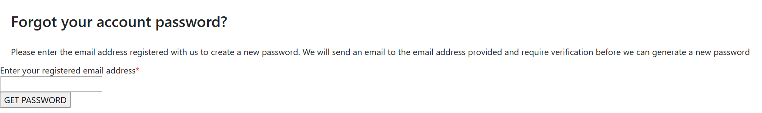

* Change password:

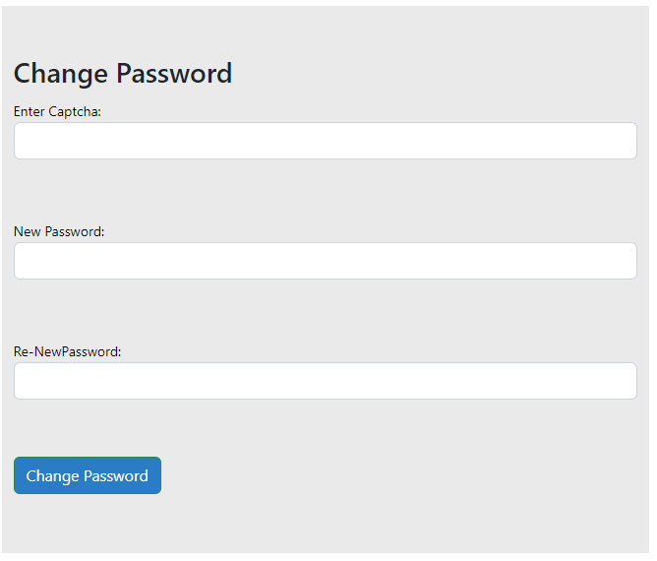

* Edit profile:

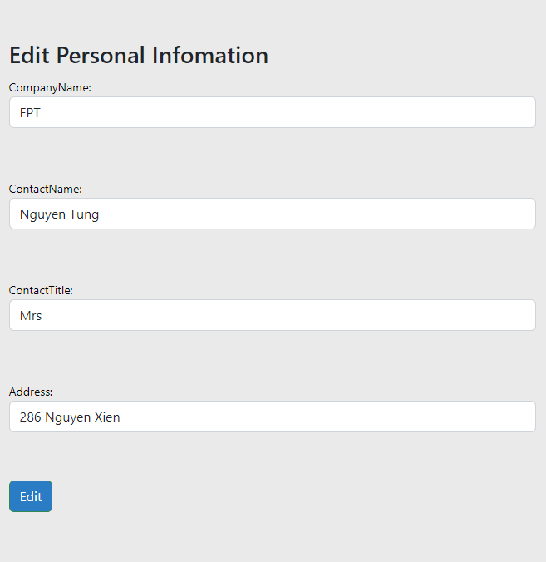

* Order:

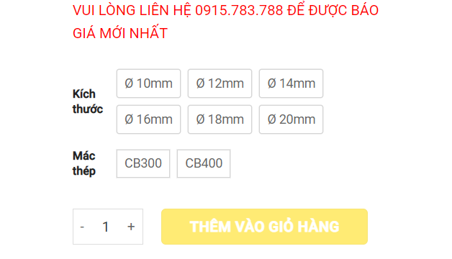

Order detail:

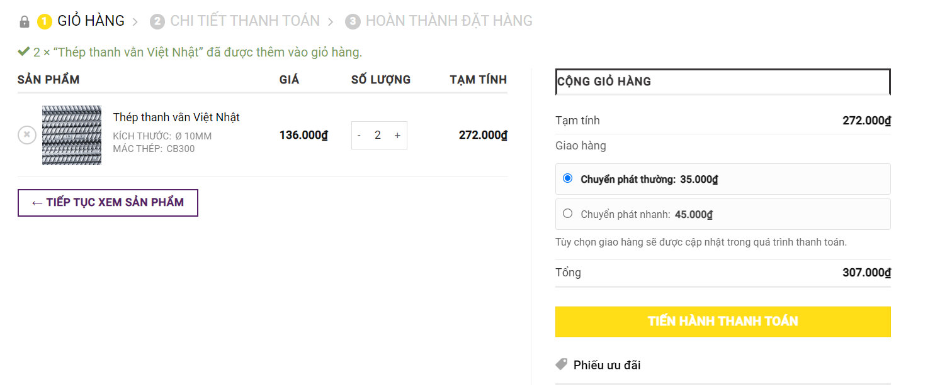

# DATA

## Archiving Policy

The data of the website will be stored in the database of the sql server.

The data includes the information of customers, employees, the detailed orders of users and some information of the website. Users can edit their profile and the order and new data will be saved in the sql. With administrators they can add, edit or delete the products, news of the website and orders of the customers

# 10 IMPLEMENTATION

Should consider the function of the administrator such as view details, add, edit and delete the information in the website. The order product of the customers and they can delete the orders before the products are delivered when they do not want to buy.